**WEB DEVELOPMENT LEARNING CURVE**

**----Atri Sengupta(223018839)**

**Custom site development involves a steep learning curve.**

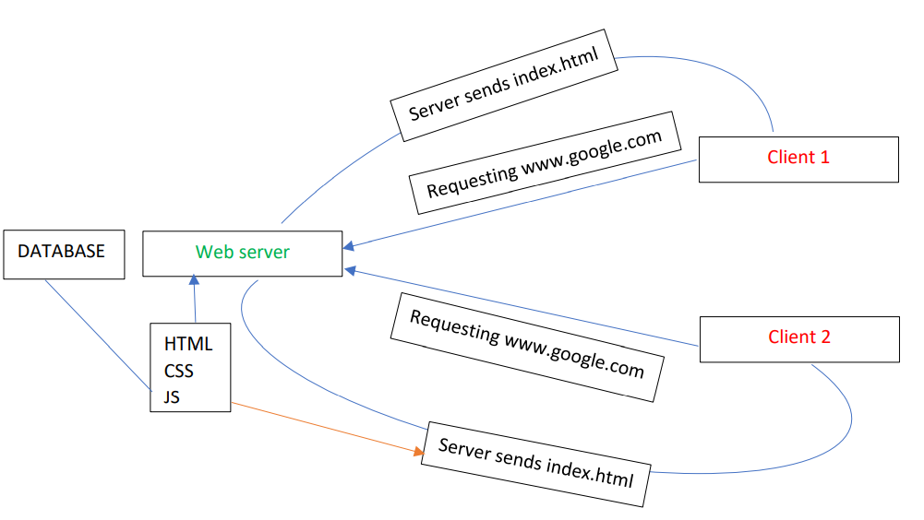

Index.html has HTML, CSS, JS combined and it will be send from server and browser will pass it to

the client. How is the HTML, CSS, JS combination generated? Its done by the backend. Backend reads

from database or file to generate it. Backend decides which response to send to which request. It

can query blogpost, images etc.

Learning curve( At best 3 months minimum):

1. Frontend basic: 1. HTML 2. CSS 3. JS→ TypeScript.

2. GIT and GitHub version control system.

3. React or framework like Angular.

4. State management: Services(Angular).

**5. So which backend language to take for absolute beginner?**

1. PHP: It is easy to learn, closest to JS. But libraries are less.

[LARAVEL framework] DATABASE: MySQL.

2. NodeJS: JS we already know by now. But JS complicated concept are involved

here. [Express framework]. DATABSE: MongoDB

3. Python: Django/ FLASK are the 2 backend frameworks. DATABSE: SQLITE.

4. SpringBoot: I used Java to code and got to know that GE REN uses SpringBoot for

backend, so before joining as a heads up, I tried preparing SpringBoot. Before

SpringBoot you need to know Spring Framework, else dependency injection and

other features wont come with clarity.

6. Relational DATABASE:

1. MySQL.

2. PostgreSQL

7. NoSQL DATABASE:

1. MongoDB.

8. Application Programming interface.

9. Traditional and Headless CMS: WordPress.

10. Deployment/devops:

1. SSH.

2. SSL certificate.

3. GitHub Actions.

4. Load balancing, Monitoring, Security.

11. Static hosting: Netify or GitHub pages.

12. Web servers: Apache.

13. Testing: Unit, Integration and Functional.

14. Virtualisation: Automate container deployment, scaling and management: Kubernetes.